Chapter 1 : “Introduction to JavaScript”- What is JavaScript?
In web-development, JavaScript is the minimalist, exciting, straight-forward programming language that controls how web pages look by making them responsive and interactive.
JavaScript is also a high-level programming language (easy to understand) and is one of the three core technologies of the web( Essential for front-end web development).
JavaScript programs the behaviour(Make the web page do things and respond to the user.)
Program- A set of instructions, written in a programming language for the computer to execute!

Example 1:
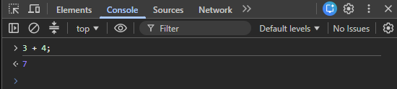
“3”- 3ones (a number)/ value(integer)
“+”- addition operator (add values)
“4”-4ones/value(integer)
“;”-semicolon: The end of the statement

Example 2:
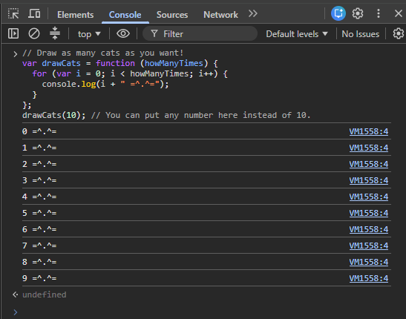
“Draw as many cats as you want!”- Comment
“var drawCats ” Naming the Variable
“function (howManyTimes) {“- Creating a function
“(howManyTimes)”- parameter
“{“- The opening brace( Everything inside these braces belongs to the function.)
“for (var i = 0; i < howManyTimes; i++) {”- The for loop.
A “for loop” repeats code: Important
“var i = 0;”-Creating a variable named “I”- i = 0
“i < howManyTimes;”- JavaScript is asking a question.
- 0 <10 (true) “i=0”
- i++= 1
- Keeps repeating( looping) until i=9 , so 0 to 9 is displayed “drawCats(10)”
i=0, i++=1 therefore i++=0+1=1.
“}”- ends the loop. “};”- ends the function.
“console.log()”- prints output to the console.( displays the output)
Chapter 1 Facts:
- Every major Browser ships with a JavaScript interpreter e.g Google chrome
- JavaScript is a responsive language that controls how the wep page looks.
- “ctrl+shift+j” opens the JavaScript console , first type “about:blank” on the URL
- Each JavaScript instruction is a statement and every statement ends with a semicolon “;”

Understanding of chapter 1:
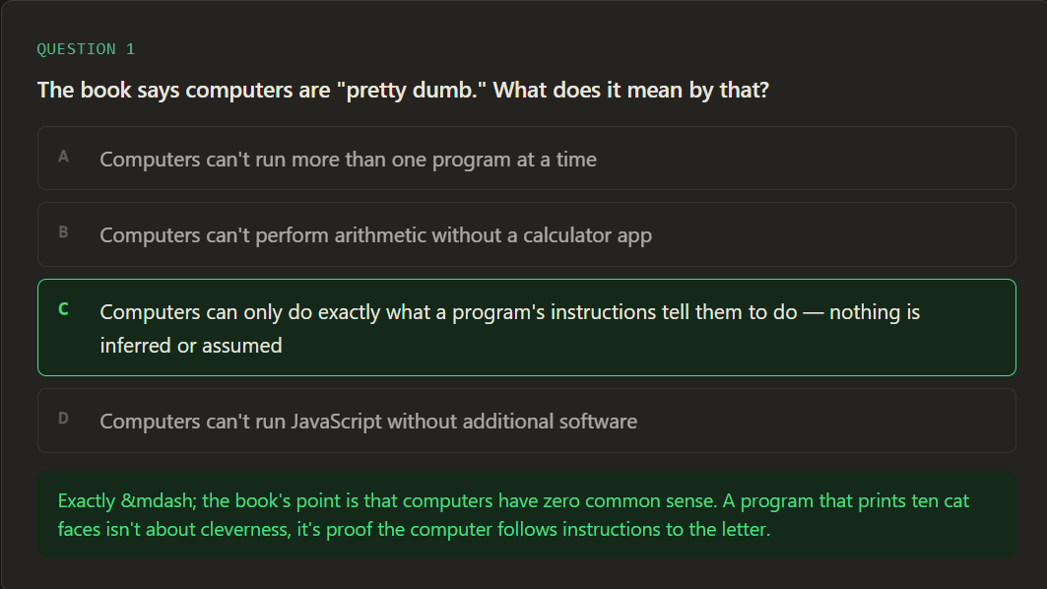
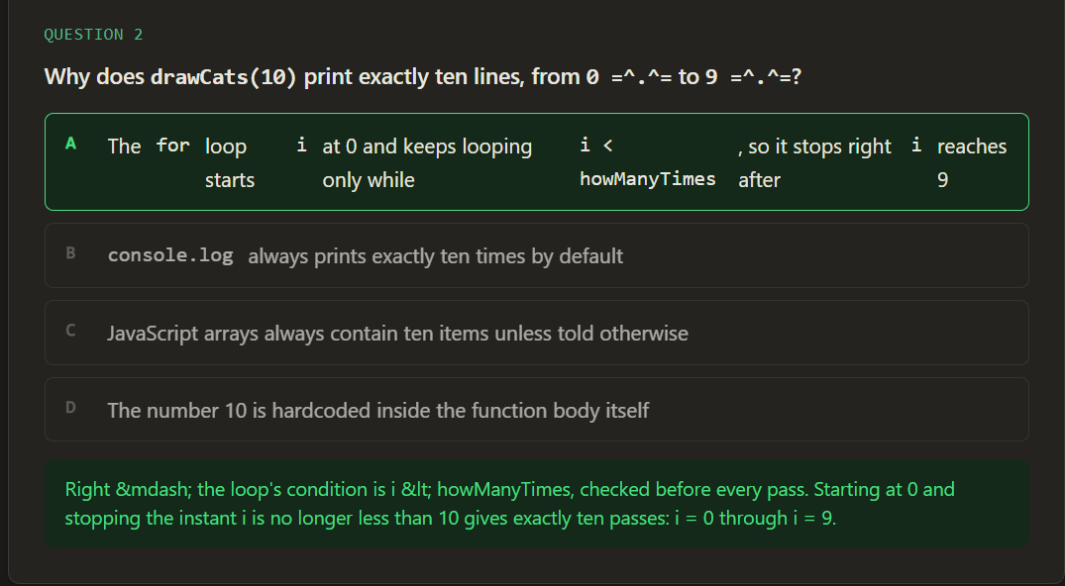

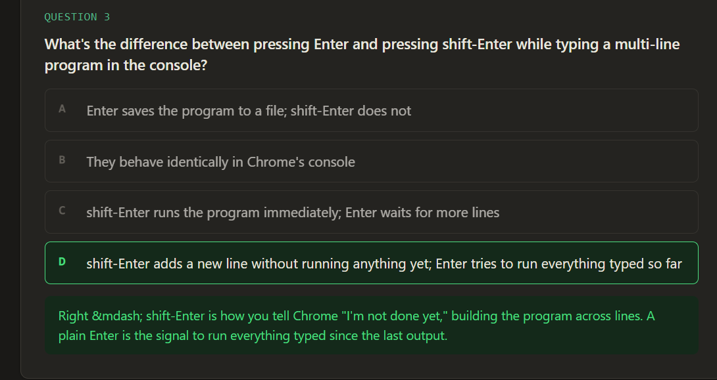
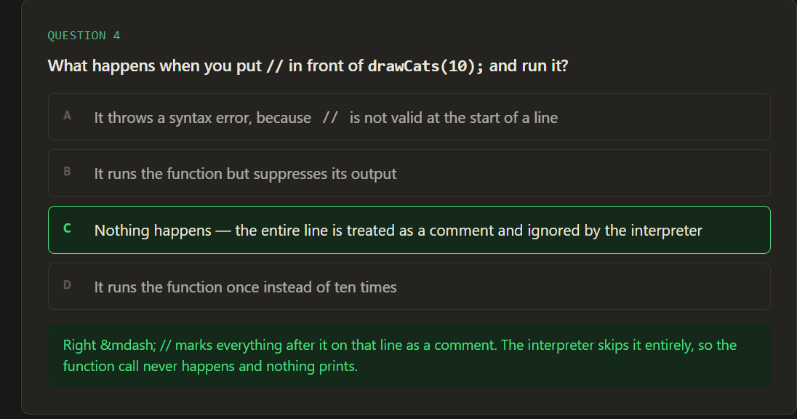
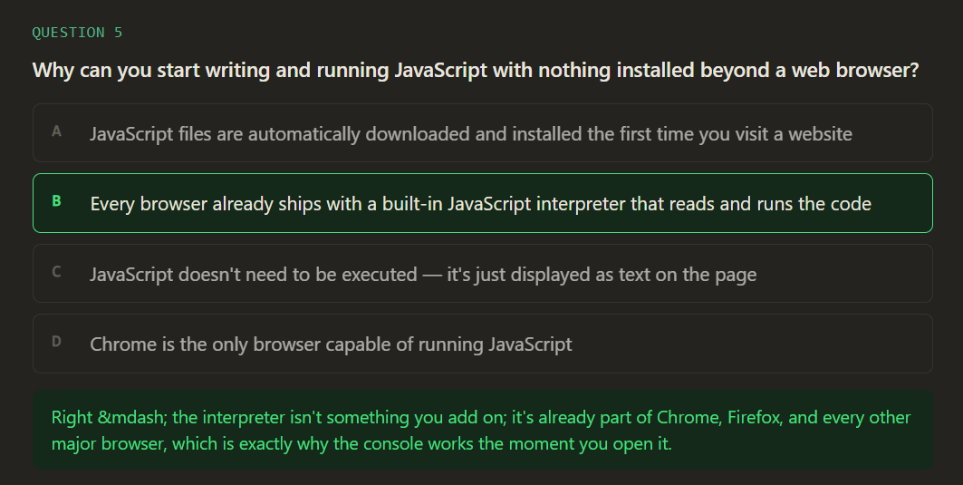

Bibliography
“Code College”
JavaScript for kids

